**MySQL notes**

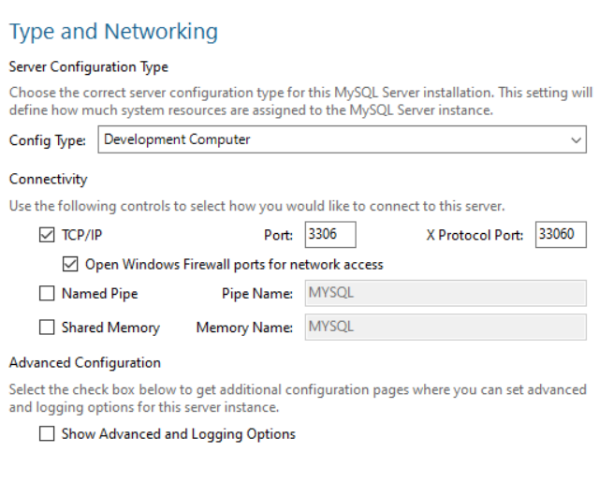

My root password: toor